**Department of Information and Communication Technology**

**Faculty of Technology**

**University of Ruhuna**

**Database Management Systems Practicum**

**ICT 1222**

**Assignment 02 – Mini Project Group**

**Group Number 15**

Submitted to: Mr. P.H.P. Nuwan Laksiri

Submitted by: TG/2022/1369 – H.K.D. Randika

TG/2022/1370 – I.D.A. Samaranayake

TG/2022/1373 – M.M. Shasan

TG/2022/1385 – K.A.M.I. Wickramasinghe

Contents

Brief introduction about the problems and solution of the project 3

Proposed ER/EER diagram 4

Proposed Relational mapping Diagram 5

Table structure of solution 6

Tools and technologies that we have used. 14

Views and Functions 15

Challenges Encountered During Solution Development 24

Solutions Implemented 24

Hosting Plans and Considerations 24

References 24

## Brief introduction about the problems and solution of the project

**Database Design Complexity**

* Problem: Designing an efficient and normalized database structure that can handle different types of data (e.g., attendance, marks) is complex and requires careful planning.
* Solution: Using the ERD and relational mapping to clearly define relationships, dependencies, and constraints between entities can help create a streamlined design.

**Handling Attendance with Medical Excuses**

* Problem: Recording attendance accurately and factoring in students with medical excuses poses a challenge, as it affects eligibility calculations.
* Solution: Implement an additional field in the attendance table for medical reasons and use conditional logic in queries to adjust eligibility calculations accordingly.

**Eligibility Calculation Based on Attendance and Marks**

* Problem: Accurately calculating eligibility for exams based on attendance (80% threshold) and continuous assessment (CA) marks (≥ 50%) for each course unit can be complex.
* Solution: Use stored procedures or views to simplify eligibility calculations and automate the process. Testing this logic with multiple cases will help ensure accuracy.

**Calculating SGPA and CGPA Accurately**

* Problem: Calculating Semester GPA (SGPA) and Cumulative GPA (CGPA) based on marks across multiple subjects and ensuring the results are accurate and consistent can be tricky.
* Solution: Use views or functions to calculate SGPA and CGPA accurately. Ensuring consistency in weightage and credits across course units is essential.

## Proposed ER/EER diagram

## Proposed Relational mapping Diagram

## Table structure of solution

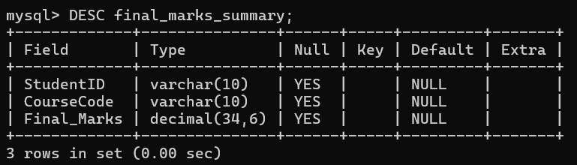

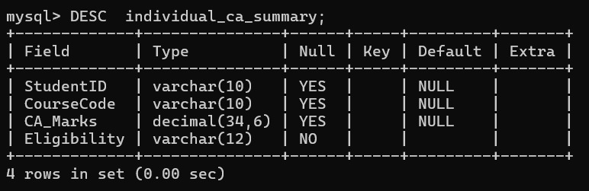

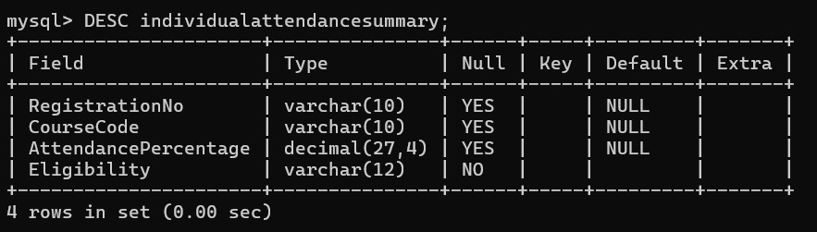

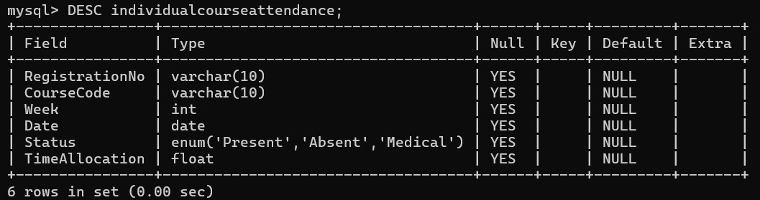

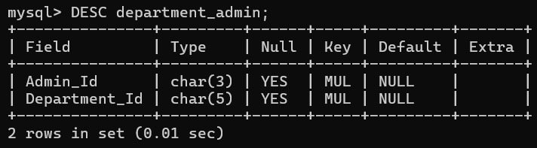

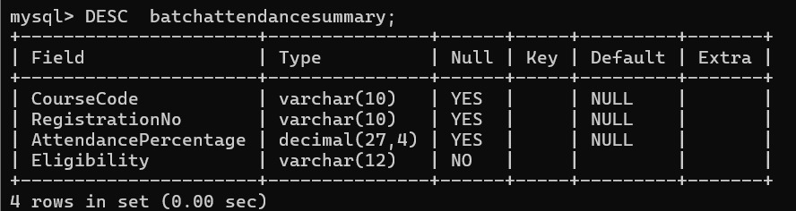

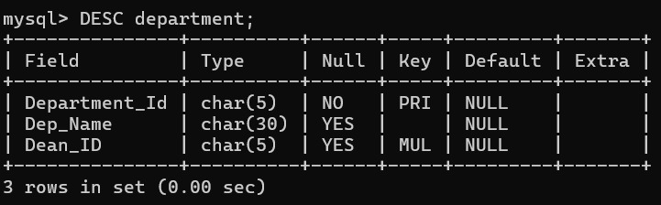

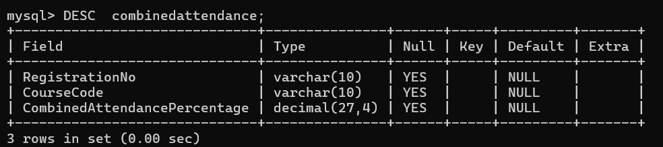

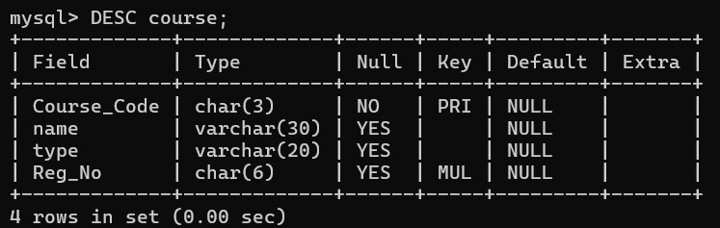

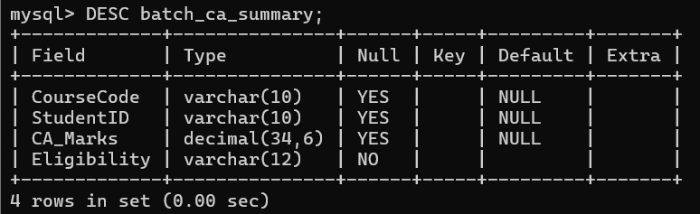

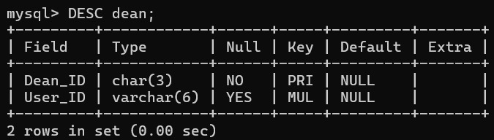

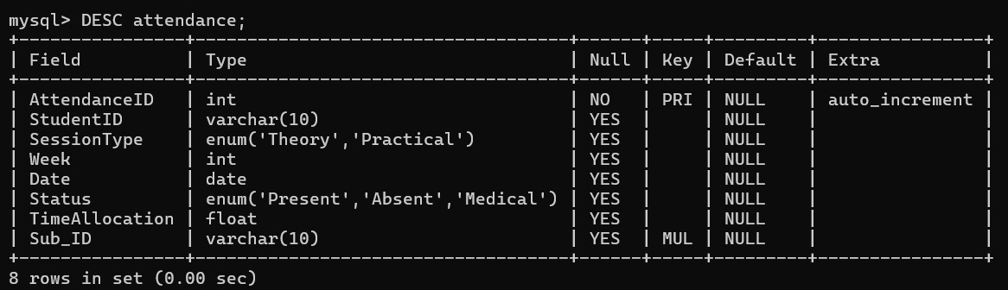

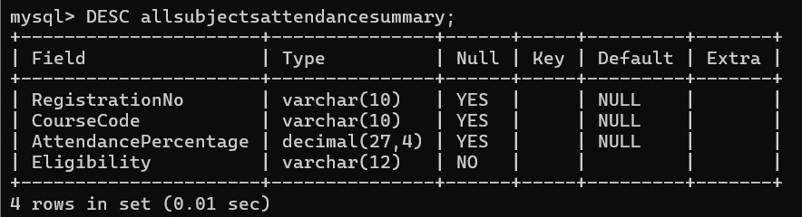

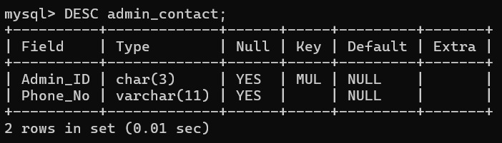

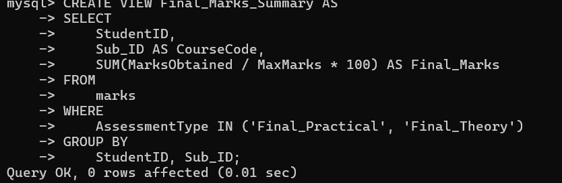

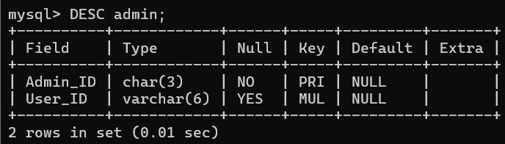

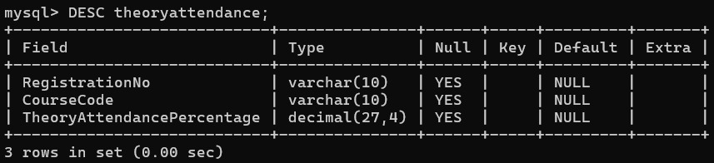

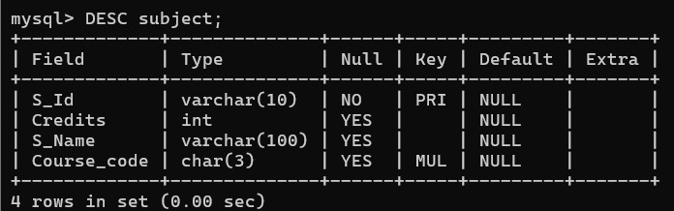

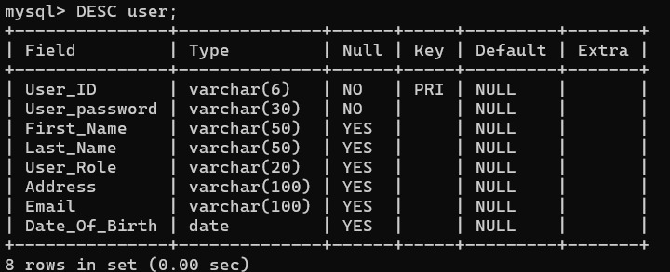

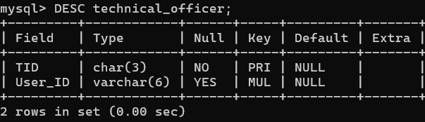

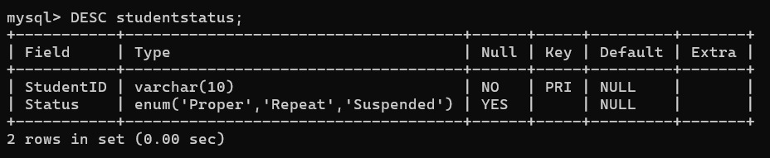

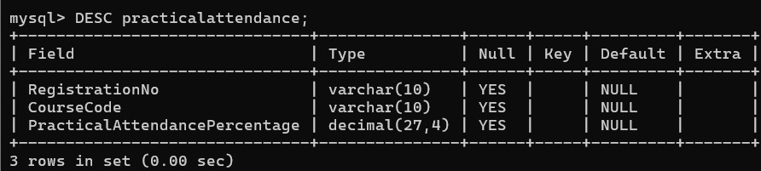

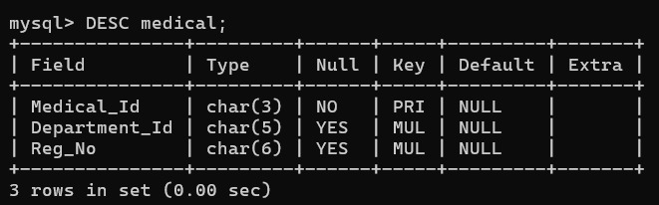

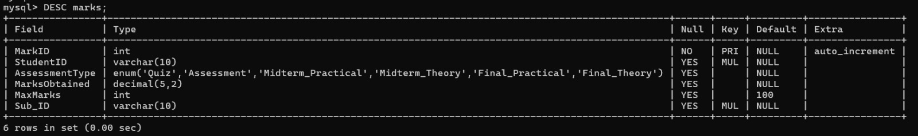

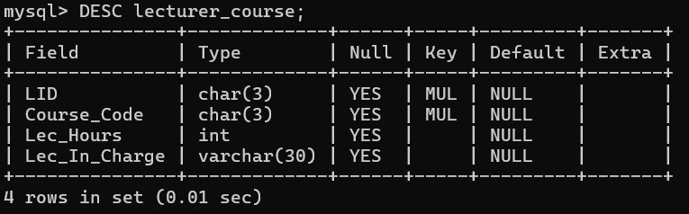

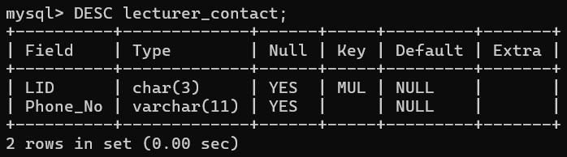

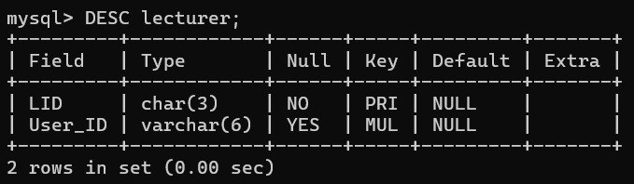

## Tools and technologies that we have used.

* Draw.io:

ER diagram

Relational schema

* MySQL SERVER, VS code, Notepad, MySQL work bench

* GitHub and GitHub Desktop:

6.Security measures that you have taken to protect your Database

|  |  |
| --- | --- |
| Admin | With All privileges with Grant Option for all the tables in the database |
| Dean | With All privileges without Grant for all the tables in the database |
| Lecturer | All privileges without Grant and user creation for all the tables in the database |
| Technical Officer | Read, write, and update permissions for attendance related tables/views. |
| Student | Read permission for final attendance and final marks/Grades tables/views. |

## Views and Functions

View attendance summary by CourseCode

View Attendance Summary for All Subjects with Percentage and Eligibility

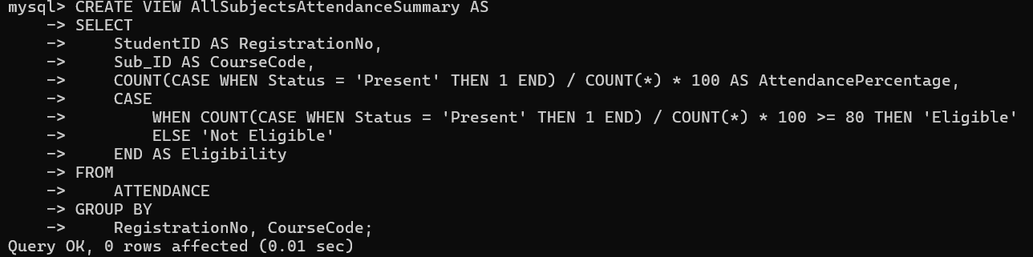

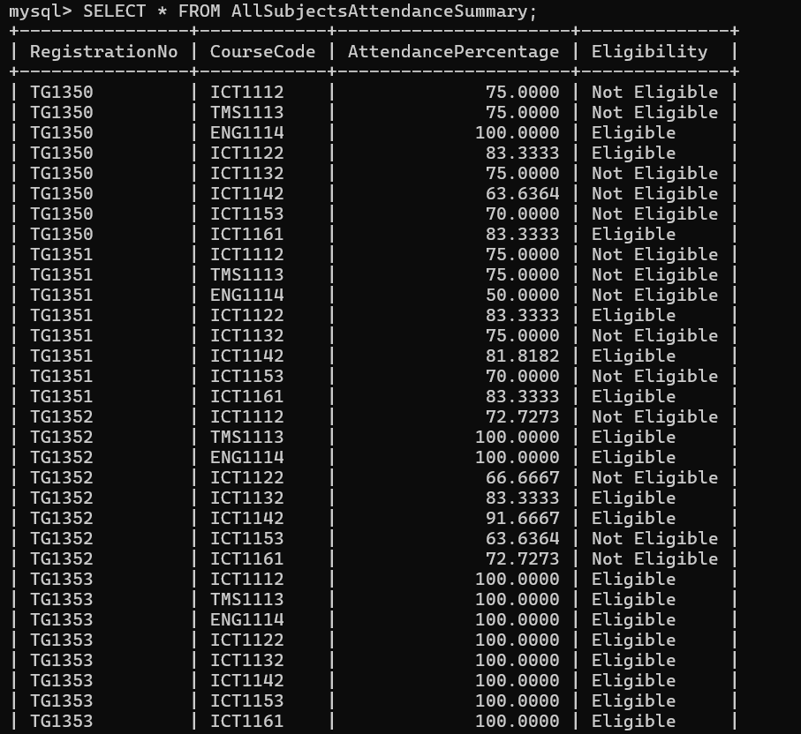

Individual Attendance Summary by Registration Number

Individual Attendance Summary by Registration Number and Course Code

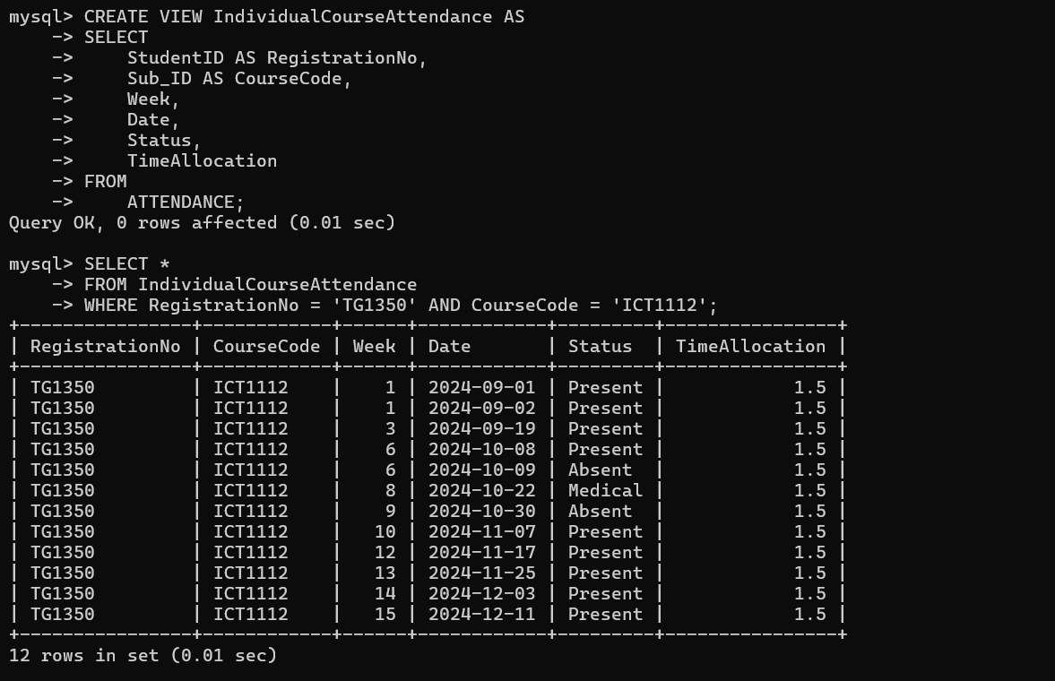

Filtered Views for Theory, Practical, and Combined Sessions

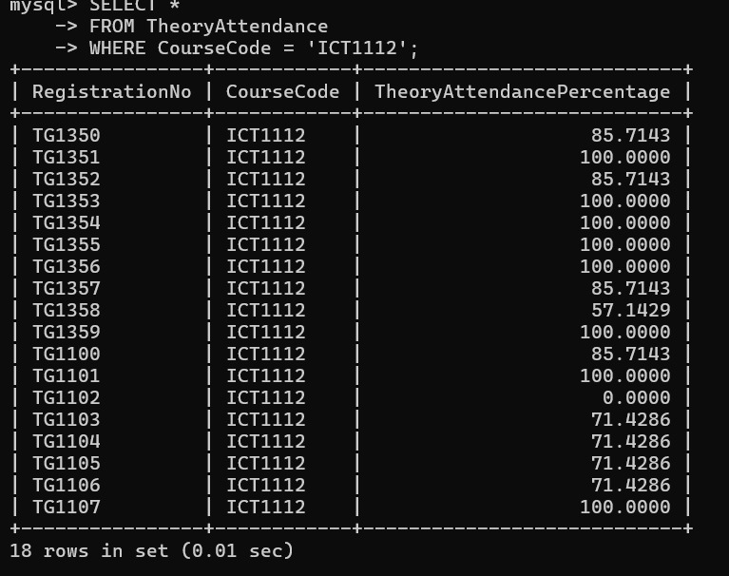

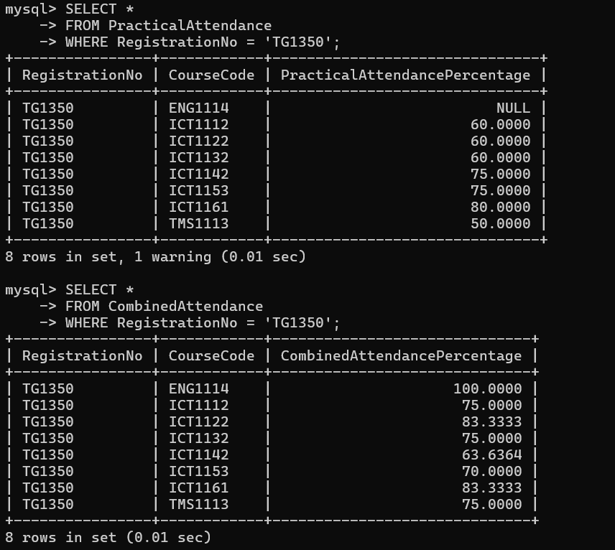

Check Eligibility Based on CA Marks

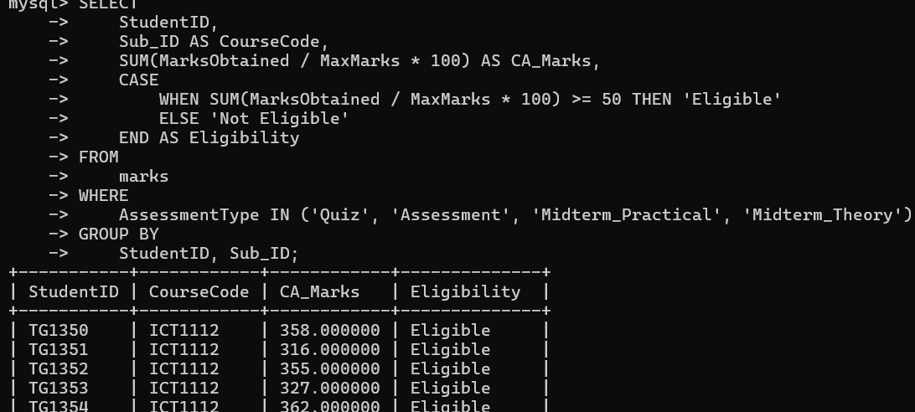

View CA Marks Summary by Course Code for the Whole Batch

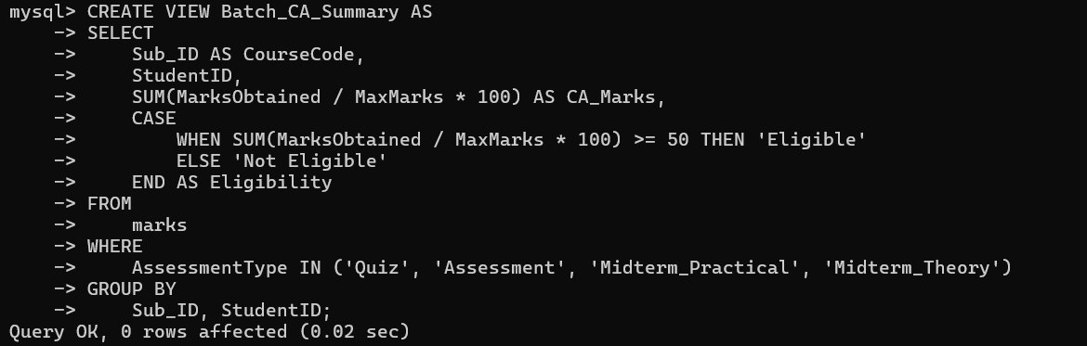

View CA Marks Summary for Individual Students

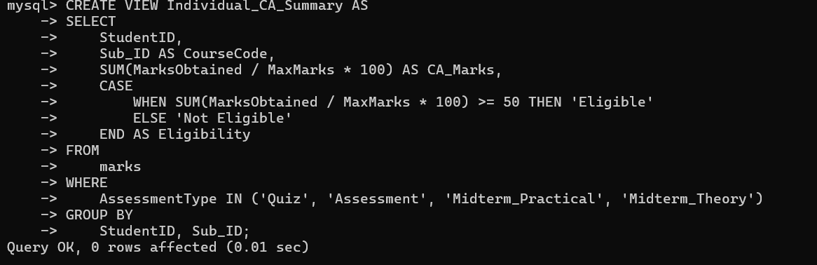

Final marks view

## Challenges Encountered During Solution Development

* Creating Complex Tables
* Data Maintenance Issues
* Diagram and Mapping Adjustments
* Data Entry Errors

## Solutions Implemented

* Separate Data Sets:

Divided attendance data across separate weekday files to streamline management.

* Automated Typing for Repetitive Entries:

Utilized automation or scripts to reduce redundant typing and improve data consistency.

## Hosting Plans and Considerations

* Platform Choice

Selecting a cloud platform enables database access from any location, real-time updates, and easier maintenance.

* Changes for Cloud Deployment

Adjust data types and optimize for cloud storage.

## References

* Lecture Notes
* W3Schools.com